Fast**National University of Computer & Emerging Sciences, Karachi  
 Spring -2020 CS-Department  
Assessment**

**11th June 2020, 11:00 am – 12:00 noon**

|  |  |  |
| --- | --- | --- |
| **Course Code: CS220** | **Course Name: Operating System** | |
| **Instructor Name / Names: Ms. Nausheen Shoaib** | | |
| **Student Roll No:** | | **Section No:** |

Instructions:

* Read each question completely before answering it. There are 4 **questions** only**.**
* ***Don’t forget to write you student ID and section.***
* ***You need to paste snap shot of your handwritten answer after each question.***
* All the answers must be solved according to the sequence given in the question paper.

**Time**: 60 minutes. **Max Marks:** 20

Q1. Consider the following code snippet in which Thread A and Thread B are running concurrently:

***[Marks= 5]***

1. Identify the problem in a following code?
2. How to solve if there is a problem in following code?

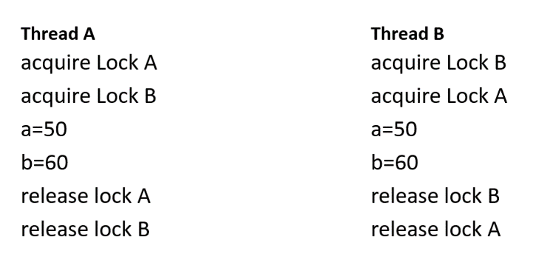

Co

Q2. Consider a situation where there are three persons sitting in a circular dining table to have their

meal. There are only two forks available. Write a pseudo code such that persons do not face any starvation and must meet mutual exclusion requirement. ***[Marks= 5]***

Q3. Consider a logical address space of 256 pages with a page size, which is your student ID ***(Ex:***

***Student ID=0253, page size= convert in nearest power of 2 that is 256KB in order to solve)***, mapped

onto a physical memory of 128 frames. ***[Marks= 5]***

(a) How many bits are required in the logical address?

(b) How many bits are required in the physical address?

***Q4. Answer following questions: [Marks= 5]***

1. Which memory management scheme has reduced the problem internal fragmentation? Explain your answer through example.
2. Why multithreaded process provides more speed as compare to processes without threads?